**Allocating Funding to Reduce Cancer Mortality**

**Goal:** create a visualization that shows how patent filings in the nine patent categories listed below correlate to changes in the cancer mortality rate over time for different age groups.

1. Drugs_and_Chemistry
2. Diagnostic_and_Surgical_Devices
3. Radiation_Measurement
4. Data_Science
5. Food_and_Nutrition
6. Model_Systems_and_Animals
7. Cells_and_Enzymes
8. Other_and_Preclassification
9. DNA_RNA_or_Protein_Sequence

A negative correlation between patents filed and cancer mortality rate is an indicator that increased research in that category may reduce cancer mortality. See Figure 1 for correlations for each patent and age category. The following categories had a strong negative correlation between patents filed and cancer mortality for all age groups except 85+:

1. Diagnostic_and_Surgical_Devices – See Figure 2.
2. Data_Science – See Figure 3.
3. DNA_RNA_or_Protein_Sequence – See Figure 4.

The age group where the negative correlation is the strongest among these three categories is 55-64 years. **Increasing funding in these areas may lead to further decreases in cancer mortality, especially in the 55-64 age group.**

Two additional categories had strong negative correlations for all age groups except 75-84 and 85+.

1. Model_Systems_and_Animals
2. Cells_and_Enzymes

**Increasing funding in these areas may lead to further decreases in cancer mortality for patients under 75. It is not known if 75 and over patients used medical procedures derived from these two categories at lower rates than patients under 75, which could explain the lack of benefit.**

Four categories showed little or no negative correlations.

1. Food_and_Nutrition – See Figure 5 as an example of poor correlation.
2. Drugs_and_Chemistry
3. Radiation_Measurement
4. Other_and_Preclassification

**Funding in these areas did not correlate well to decreased cancer mortality**

Figure 1. Correlations between patents filed and cancer mortality for different age groups.

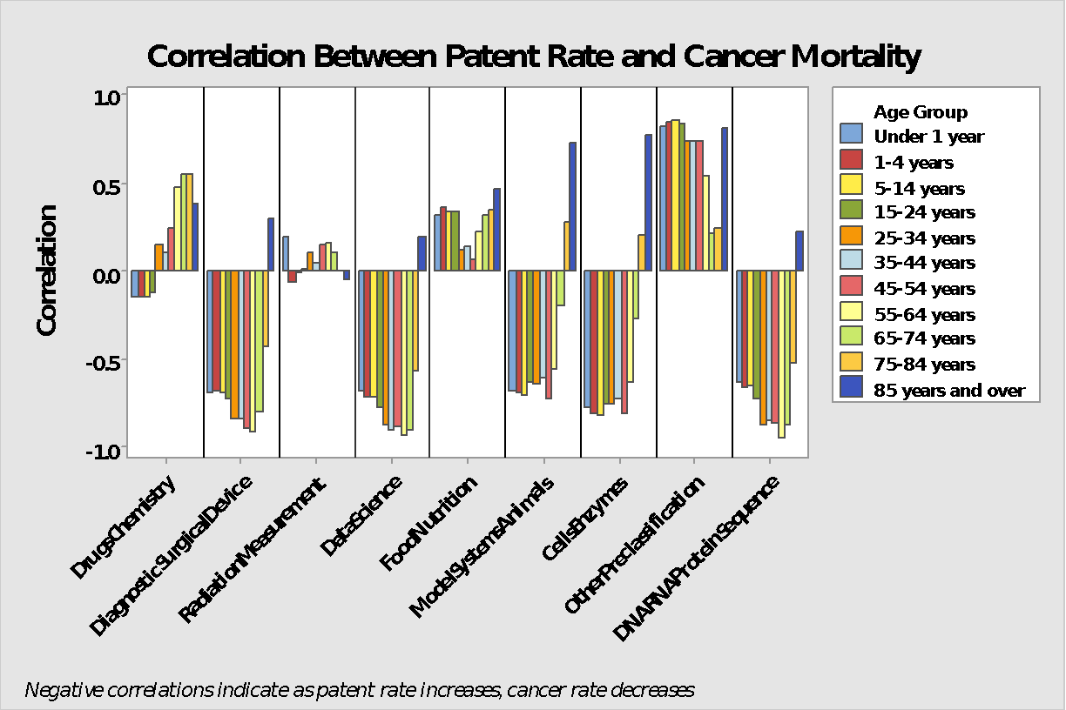

Figure 2. Mortality Rate and Proportion of Patents Filed vs Year for Diagnostic and Surgical Device category and 55-64 age group.

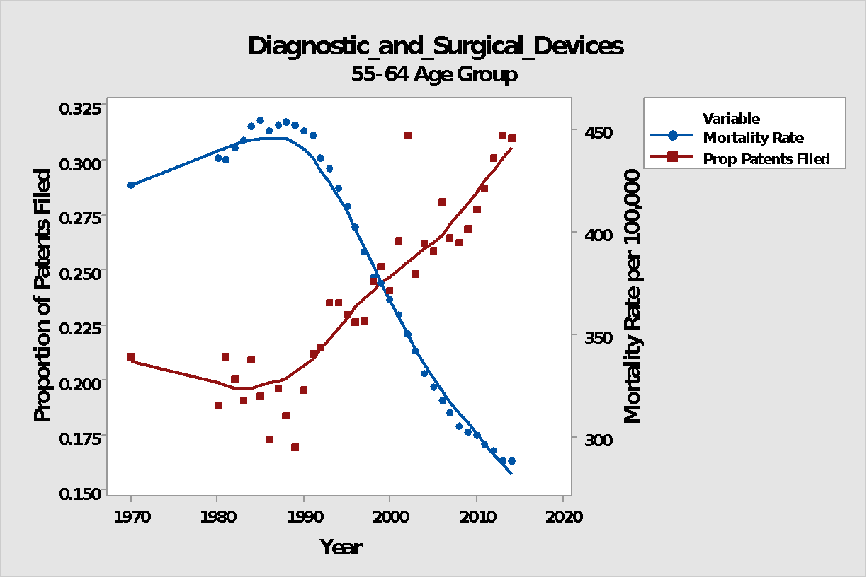

Figure 3. Mortality Rate and Proportion of Patents Filed vs Year for Data Science category and 55-64 age group.

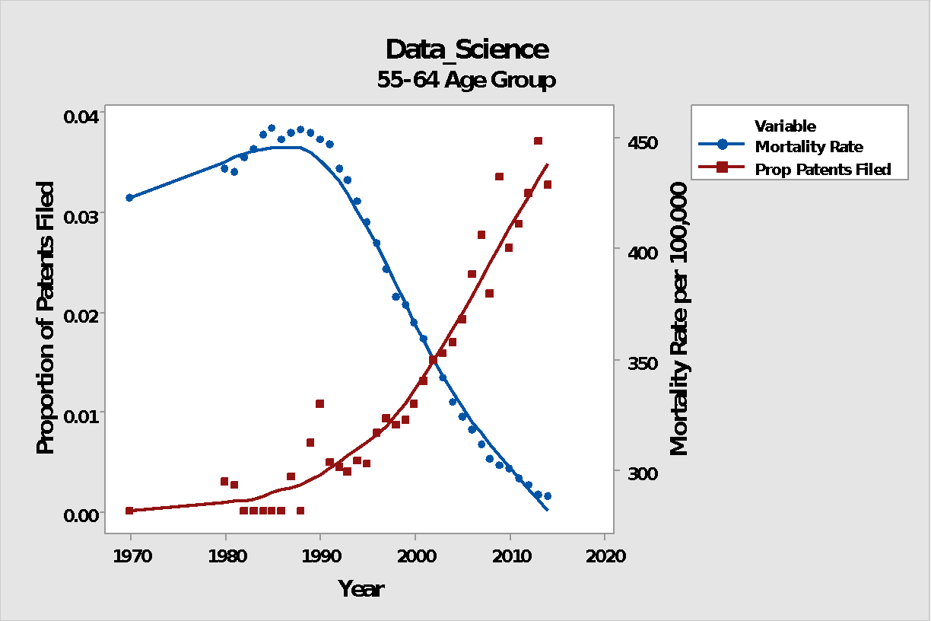

Figure 4. Mortality Rate and Proportion of Patents Filed vs Year for DNA, RNA, or Protein category and 55-64 age group.

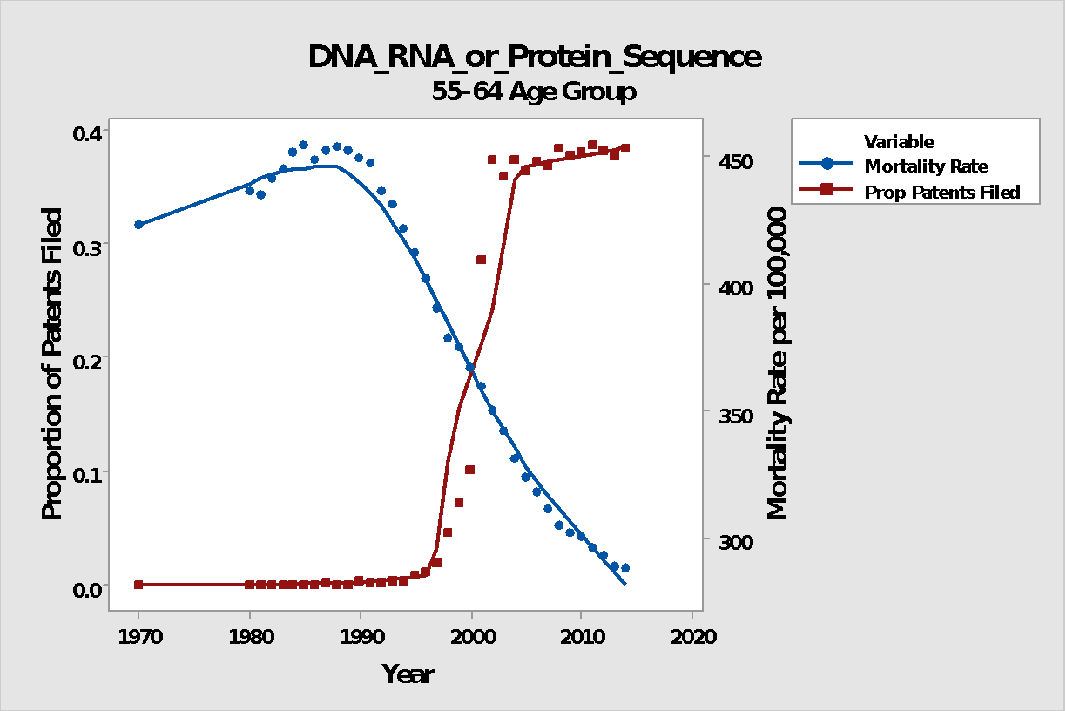

Figure 5. Mortality Rate and Proportion of Patents Filed vs Year for Food and Nutrition category and 55-64 age group.

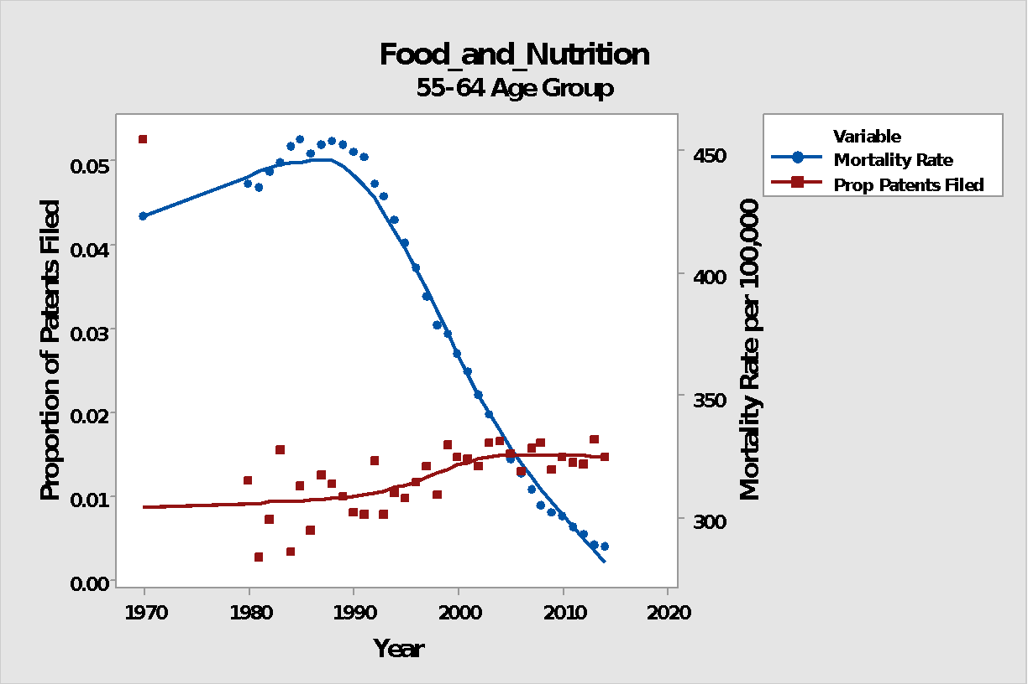

Figure 6. Bar Chart showing patents granted over time.

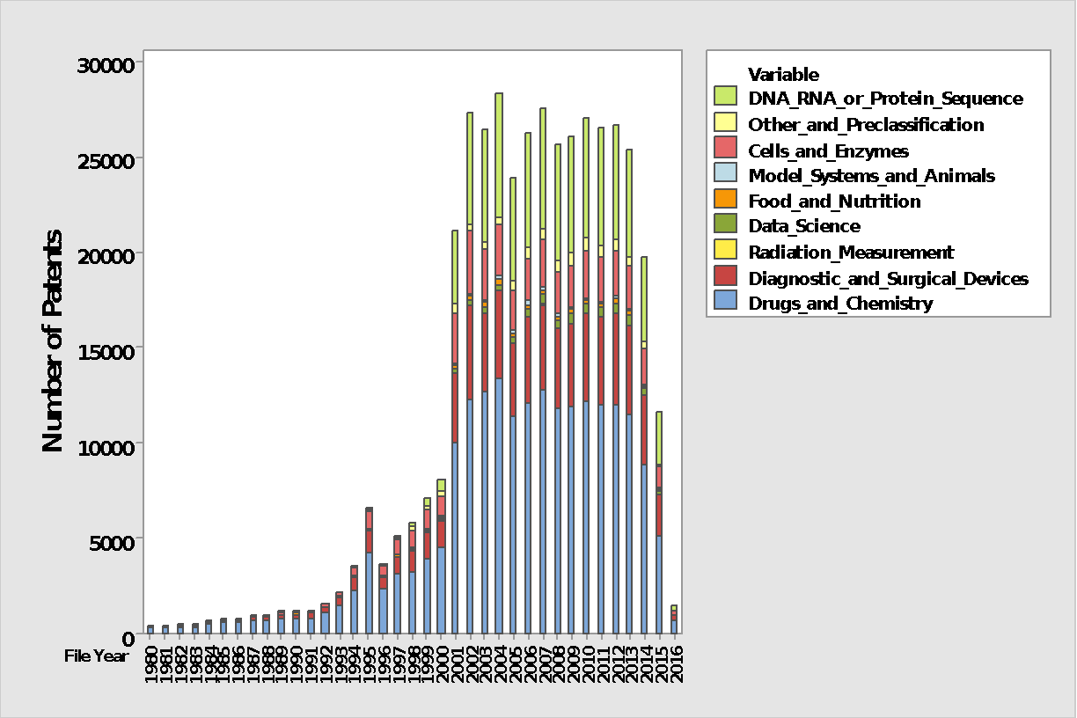

**Data Notes**

External Data Source Used: **CDC National Center for Health Statistics** malignant neoplasm death rates per 100,000 resident population for years 1970 and 1980-2014 by age group. The age groups available are:

1. Under 1
2. 1 to 4
3. 5 to 14
4. 15 to 24
5. 25 to 34
6. 35 to 44
7. 45 to 54
8. 55 to 64
9. 65 to 74
10. 75 to 84
11. 85 and Over

The number of patents filed in the CancerData12A.csv dataset was low in recent years since only approved patents were included. See Figure 6. In result, instead of using the annual number of patents filed from a category as a predictor of cancer mortality, the annual *proportion* of patents for each category was used. The annual proportion was calculated as the number of patents filed in a given year for a particular patent category divided by the total number of patents filed that year across all categories. This is an indicator, for each year and category, of the resources allocated to each category.

**Testing and Usage**

The Patent_and_Mortality_Data.xlsx file contains the variables used to create the graphs in this submission.